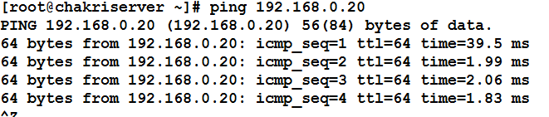

# rpm -ivh https://yum.puppetlabs.com/el/6.5/products/x86_64/puppetlabs-release-6-10.noarch.rpm





yum install puppet